Top 500 locations are observed sorted by number of traffic accidents, from

Top 25 locations with the highest number of traffic accidents. Points to major highways and congested downtown area. Number of incidents ranging from 125 – 265. (avg XX annualized)

Image1

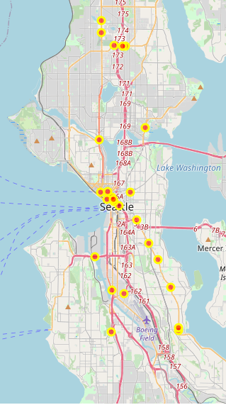

Image2- zoom to downtown

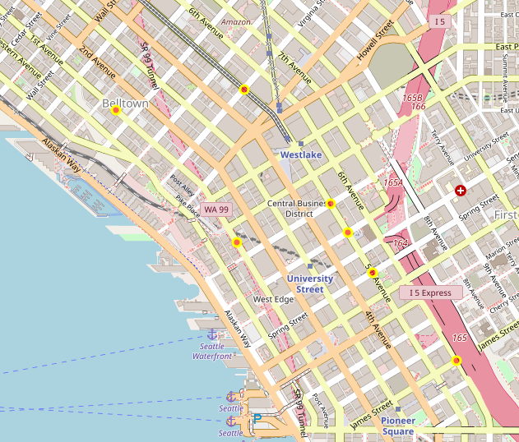

Image 3- zoom north seattle

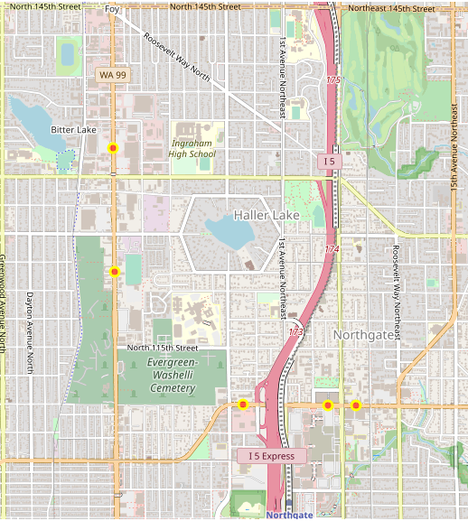

Top 100: High number of incidents on certain streets in Downtown Seattle, namely 1st avenue and 5th avenue

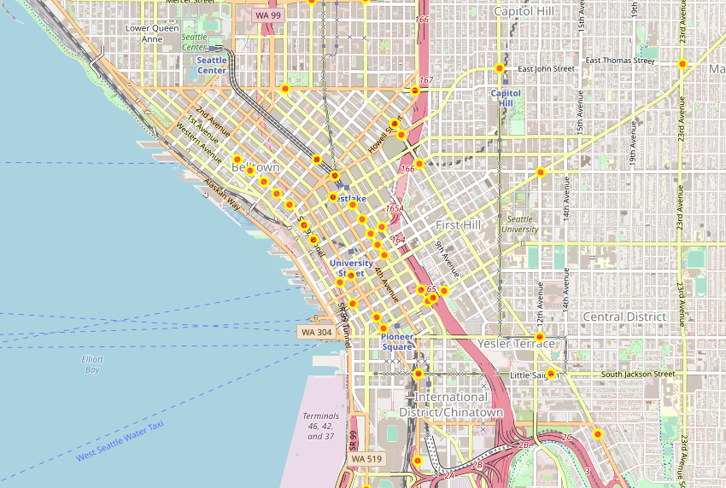

Image 2 – north seattle

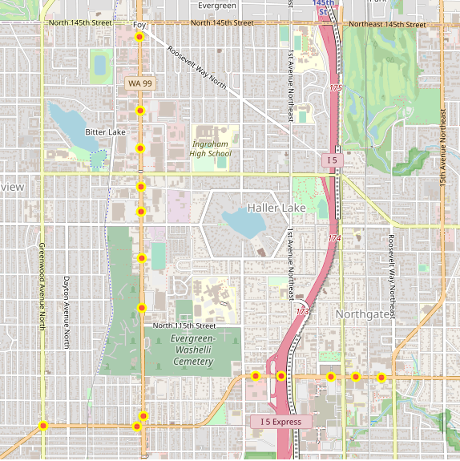

Image 3- south of downtown

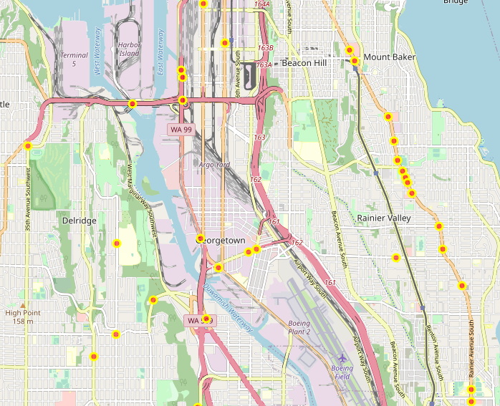

Top 6 highest- range 212 – 265 (200s)

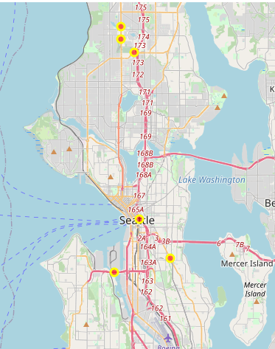

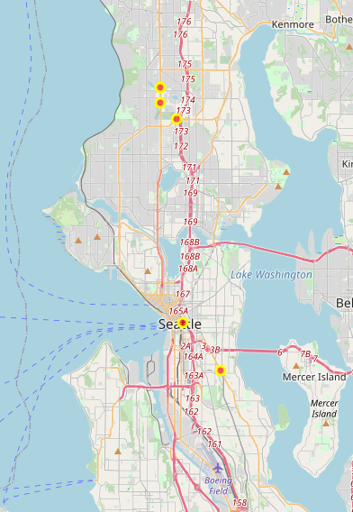

NO Notable diff in location for level 1 vs level 2- top 100 incidents in each level

Image 1- level1

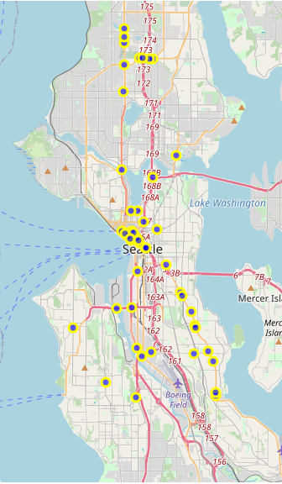

Image 2 – level2

